Safir
Xi tkj
https://letsdefend.io/blog/how-to-install-and-configure-snort-on-ubuntu
sudo nano /etc/snort/snort.conf
sudo nano /etc/snort/rules/local.rules

suricata
/etc/suricata/suricata.yaml

Command
sudo apt install suricata-update -y
sudo suricata-update
step
apt update
apt install snort
pas gui muncul masukin ip vm/32 atau bisa juga di file /etc/snort/snort.conf
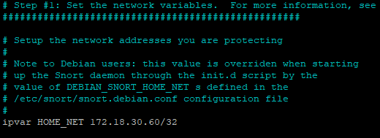
Sudo nano /etc/snort/snort.conf
Csv
To generate log files to examine alerts for the rule matching traffic pattern, we can use several methods. In this article we will write the logs to CSV files and PCAP files.
To generate logs in CSV files, the following line in the snort.conf file should be added to the “Configure output plugins” section.
Di file snort.conf output alert_csv: /var/log/snort/alert.csv default
to generate logs in PCAP files, the following line in the snort.conf file should be added to the “Configure output plugins” section.
Di file snort.conf output log_tcpdump: /var/log/snort/tcpdump.log

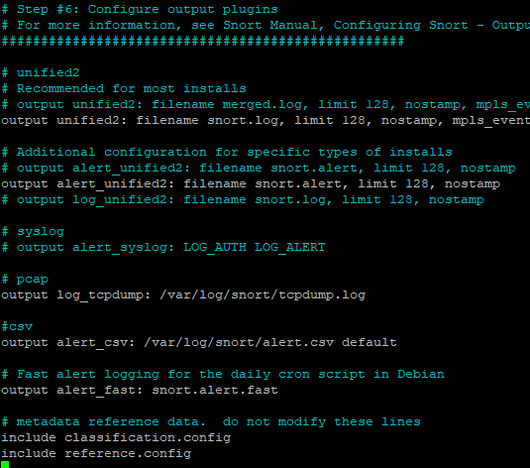
Rules
Snort rules consist of two parts which are Rule Header and Rule Options.
Rule header contains the Rule’s Action, Protocol, Source IP Address, Source Port, Direction, Destination IP Address and Destination Port information.
Rule options form the heart of Snort’s intrusion detection engine combining ease of use with power and flexibility. All Snort Rule Options are seperated from each other using semicolon(;). Rule option keywords are separated from their arguments with a colon(:).

Cara kerja rules
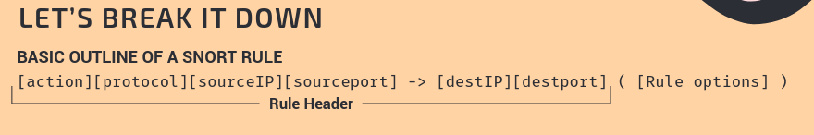
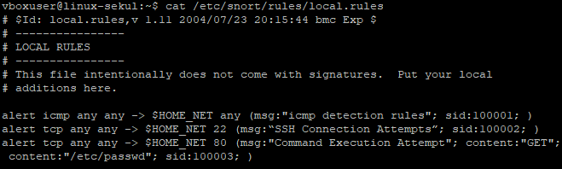
Testing ping dari cmd (host laptop) dan ssh dari putty (host laptop)
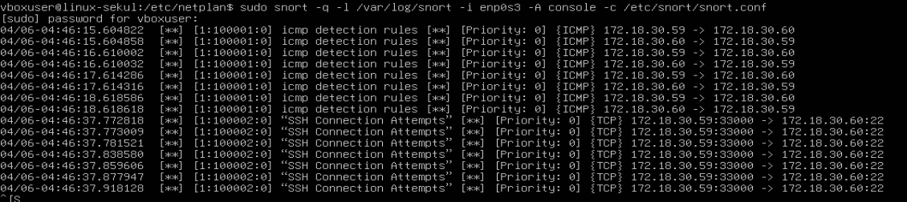

Test Test the Command Execution Attempt Detection Rule
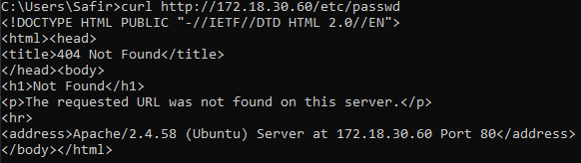
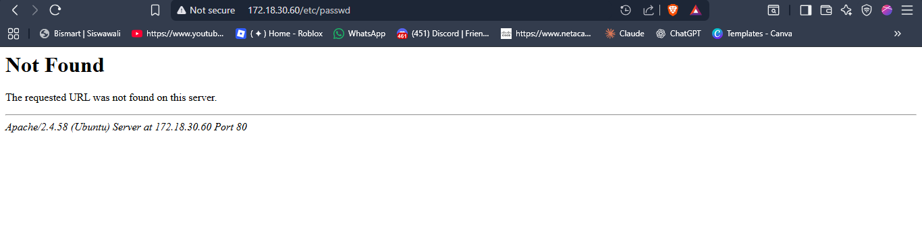
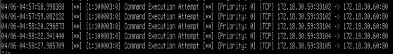

Suricata
